MED D - Blue MedicareRx (NEJE) - Cancellation of Voluntary Disenrollment

Submitting a Cancellation of Disenrollment Request
DISENROL-NEW MCO
NOT ENROLLED
Related Documents

Description: This document provides the Blue MedicareRx (NEJE) CCR with the proper guidance in addressing questions, concerns and issues surrounding a beneficiary’s request to cancel a voluntary disenrollment request.

Submitting a Cancellation of Disenrollment Request
To submit a request for cancellation of disenrollment prior to the disenrollment effective date, the CCR will:

NEJE CCRs Only: NEJE CCR will need to receive Supervisor or NEJE dedicated Senior approval to submit the cancellation of disenrollment request.

Step | Action
1 | From the Medicare D Inquiry Tab in PeopleSafe, review the Benefit Effective date and the Benefit Expiration date.  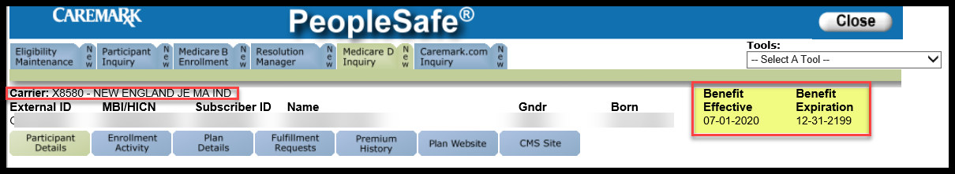
1 | If the cancellation request is received… | Then…
1 | AFTER the Benefit Expiration date | The beneficiary cannot cancel their disenrollment. They are no longer enrolled in the plan.  Note: The beneficiary will be able to enroll during the next AEP or if they have a valid Special Election Period (SEP).  - You were disenrolled as of <Benefit Expiration date >. We are unable to cancel your disenrollment.  - You will no longer be enrolled in the plan.  - You may submit an enrollment application if you have a valid election period (or during AEP).  - I’d be happy to see if you qualify for a valid election period.
1 | BEFORE the Benefit Expiration date | Proceed to next step.
2 | From the Medicare D Inquiry - Participant Details tab in PeopleSafe, review the Disenrollment Reason field  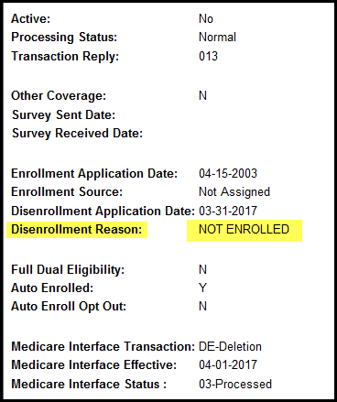  Note: A cancellation of disenrollment request may only be submitted if the beneficiary previously requested disenrollment from our plan. The Plan CANNOT disenroll or cancel the enrollment for a beneficiary from a different plan.
2 | If disenrollment reason is… |  | Then…
2 | DISENROL-NEW MCO |  | Proceed to DISENROL-NEW MCO.
2 | NOT ENROLLED |  | Proceed to NOT ENROLLED.
2 | Any other reason |  | Refer to the MED D - Blue MedicareRx (NEJE) - PeopleSafe Disenrollment Reason - Processes and References .

Top of the Document

DISENROL-NEW MCO

The beneficiary must contact the other plan to cancel their future enrollment if they wish to remain enrolled in our Plan.

Perform the steps below:
Step | Action
1 | - Our records show that you will be disenrolled from Blue MedicareRx on XX/XX/XXXX due to enrolling into another Part D plan. Since Blue MedicareRx did not submit the disenrollment request, we are unable to cancel the disenrollment for you.  - If you would like to remain enrolled with Blue MedicareRx, you will need to contact the plan you enrolled in and cancel your enrollment.  - Another option is for you to complete a new enrollment request for the plan you wish to be enrolled in. However, please be aware you will need to have a valid enrollment period (i.e. AEP or SEP) for this enrollment to be accepted.  Notes:  - DO NOT send an RM Task.  - If the beneficiary does not know the plan they have enrolled into, verify in MARx which Plan the beneficiary has enrolled with.  - If the beneficiary states that an enrollment was submitted against their wishes, they may contact 1-800-633-4227 (1-800-MEDICARE) for further assistance.  Proceed to next step.
1 | If… |  |  | Then…
1 | Beneficiary wants to enroll |  |  | - You may submit an enrollment application if you have a valid election period (or during AEP).  - I’d be happy to see if you qualify for a valid election period.
2 | Have you contacted the other plan to cancel your future enrollment?
2 | If… | Then…
2 | The beneficiary has NOT contacted the other plan to cancel their enrollment. | Note: Do NOT send a RM task.  Please contact the plan you enrolled in and submit a request to cancel your future enrollment. Once we receive information showing the enrollment has been cancelled, you will receive a letter in the mail.
2 | The beneficiary has contacted the other plan. | Verify in MARx if beneficiary’s future enrollment is cancelled and beneficiary is reinstated into the Plan.  Note: Contact the Senior Team (SRT) for assistance with:  - Reviewing MARx Part D eligibility; and/or  - Opening Access to Care if necessary (if the beneficiary is not enrolled and has 3 days or less of medication on hand).
2 | The beneficiary has contacted the other plan. | If other plan is… | Then…
2 | The beneficiary has contacted the other plan. | Not cancelled in MARx. | Inform the beneficiary they may contact Medicare toll-free at:  1-800-633-4227  <24 hours a day, 7 days a week>.  TTY users call < 1-877-486-2048 >.
2 | The beneficiary has contacted the other plan. | Is cancelled in MARx and the beneficiary has not been reinstated. | We are only able to process your reinstatement once we have received notice from Medicare. When your reinstatement has been approved and processed, you will receive a letter in the mail. Please note, this may take up to 10 days or more during busy times of the year such as the Annual Enrollment Period.
3 | - Thank you for your time today.  - As a quality measure, have I fully answered and resolved <your/the beneficiary’s> question(s) to <your/the beneficiary’s> satisfaction?
3 | If... | Then...
3 | Yes | Close the call:  - Address any benefit issues.  - Document and close the call according to existing policies and procedures, including all options discussed. Refer to the MED D - Call Documentation work instruction.
3 | No | - Ask additional probing questions to attempt to resolve remaining questions or concerns.  - If unable to resolve the questions/concerns, transfer the call to a Supervisor.

Top of the Document

NOT ENROLLED

Perform the steps below:
Step | Action
1 | Have you already submitted a request to cancel the disenrollment?
1 | If beneficiary says… | Then...
1 | Yes | CCR Process Note: Check within View Comments under Medicare D Inquiry tab in PeopleSafe to determine if a cancellation of disenrollment request was already submitted.
1 | Yes | If cancellation of disenrollment request… | Then…
1 | Yes | Can be found | - I can see you have already submitted a cancellation of disenrollment request.  - The request is pending processing and we would not submit another request at this time.  Proceed to Step 3.
1 | Yes | Cannot be found | I do not see that a cancellation of disenrollment request has been submitted.  Proceed to next step.
1 | No | Proceed to next step.
2 | Submit the following RM Task to request a cancellation of disenrollment:  Task Category: Med D Enrollment - Disenrollment  Task Type: Cancellation of Voluntary Disenrollment  Queue: Med D Enrollment Task  Notes: Document detailed information in the task note such as a phone number for the beneficiary and reason for cancellation.  Note: Do not give out confirmation numbers for tasks. Member services cannot verify these numbers.  You will receive written notification regarding the decision.  Copy and paste the notes from the RM task to document your call.  Proceed to next step.
3 | - Thank you for your time today.  - As a quality measure, have I fully answered and resolved <your/the beneficiary’s> question(s) to <your/the beneficiary’s> satisfaction?
3 | If... | Then...
3 | Yes | Close the call:  - Address any benefit issues.  - Document and close the call according to existing policies and procedures, including all options discussed. Refer to the MED D - Call Documentation work instruction.
3 | No | - Ask additional probing questions to attempt to resolve remaining questions or concerns.  - If unable to resolve the questions/concerns, transfer the call to a Supervisor.

Top of the Document

Related Documents
- Grievance Standard Verbiage (for use in Discussion with Beneficiary) section in MED D - Grievances Index
- MED D Enrollment - FAZAL
- MED D - SHIP Counselor Calls for CVS Caremark Part D Plans
- MED D - Appointed Representative Form (AOR) or Power of Attorney (POA)
- MED D - SilverScript and Blue MedicareRx (NEJE) - Enrollment Related RM Tasks
- MED D - Election Periods for Enrollment and Disenrollment (AEP, IEP, SEP)
- MED D - CMS Passive Enrollment in MMP - Required Voluntary Disenrollment from the PDP, Opt-Out and Disenrollment from the MMP

Parent SOP:
- MEDS-0041: Medicare Part D Voluntary Disenrollment, CVS Caremark Part D Services, L.L.C., Policy and Procedure
- MEDS-0006: Medicare Part D - Cancellation of Enrollment and Disenrollment Policy and Procedure, CVS Caremark Part D Services, L.L.C.
- CALL-0048: Medicare Part D - Customer Care Call Center Requirements, CVS Caremark Part D Services, L.L.C.
Abbreviations/Definitions:
- Abbreviations / Definitions

Top of the Document

Not To Be Reproduced Or Disclosed to Others Without Prior Written Approval
ELECTRONIC DATA = OFFICIAL VERSION – PAPER COPY = INFORMATIONAL ONLY

